# TNXP

February 9th, 2020

1.6450 (+6.13%) as of today, 13:24

Market cap: 435.558 million

16 full time employees

Yahoo finance: “1y target estimate: $3.25”

<http://www.tonixpharma.com>

Chatham, NJ

## Earnings

Next earnings: Mar 22-26th

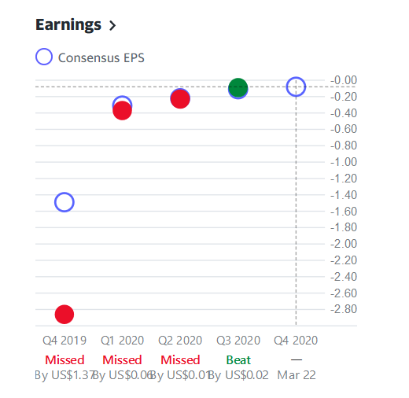

## Holders

% held by institutions: 5.25%

% held by insiders: 0.05%

Institutional holders (all hold 0.56% or less): Blackrock, GSA, Geode, Vanguard, Squarepoint, etc…

Mutual funds: Fidelity, Vanguard, Bridgeway

## Financials (Thousands)

|  |  |  |  |
| --- | --- | --- | --- |
|  | **TTM** | **2019-12-31** | **2018-12-31** |
| R&D | 29750 | 18192 | 17558 |
| Operating Expenses | 42222 | 28828 | 26322 |
| Net Income | -42149 | -28618 | -26089 |
| EBITDA | - | -28802 | -21221 |
| Total Assets | 13948 | 26056 | 26443 |
| Liabilities | 5141 | 2655 | 2138 |
| Cash at end of period | 55914 | 11349 | 25134 |

## Stock Offerings:

January: common stock offering at $40M common stock offering at $0.80.

TODAY: stock offering at $1.20 of 58.33 million shares, $70 million worth.

## Products

TNX-1800 (Coronavirus): partnership with Southern Research Based on Tonix’s proprietary horsepox vaccine. Currently being developed and tested, presumably to be done monkey trials this quarter. This uses T-Cells, so basically anyone can get the vaccine. Fujifilm to be manufacturing partner for this. Doesn’t have to be stored in low temperatures, so it could save a lot of money.

TNX-801: like TNX-1800. Idk what the difference is.

TNX-2100: diagnostic covid skin test. intended to be developed, to measure T-cell immunity to SARS-CoV2, which causes coronavirus. Researchers believe T-cell immunity can help protect against severe forms of the disease. Stock offering might have been done to fund the research for this.

TNX-102: treats Fibromyalgia symptoms, a pain disorder. Taken under the tongue as a disintegrating pill. Still being developed for long term use. In phase 3 trials, basis for exclusitivity. It is covered by issued and pending worldwide patents. Patents owed outright by Tonix. GlobalNewsWire: the Fibromyalgia treatment market expected to surpass $3.6 bill by 2026. ([link](https://www.globenewswire.com/news-release/2019/05/10/1821834/0/en/Fibromyalgia-Treatment-Market-to-Surpass-US-3-607-3-Million-by-2026-Coherent-Market-Insights.html)) Less than 3 drugs approved to treat this.

TNX-601: for major depressive disorder (depression). Can also be used for PTSD. Oral formulation. Tnoix filed a patent for a novel salt polymorph based on TNX-601. Patents owned outright.

TNX-102 SL: Agitation in Alzheimers Disease (AAD). Currently, no FDA approved treatments for AAD. Has been designated by FDA as a Fast Track Development program. A final phase 2 protocol has been submitted to the FDA for final review. Has filed patents.

TNX-801: a potential smallpox-preventing vaccine based on horsepox virus. Intends to meet with the FDA regarding this. Filed patents for worldwide rights.

TNXP-1500: used to prevent and treat organ rejection. Working with Mass General Hospital.

## Purchases

They bought two big places outright: land in Hamilton Montana for manufacturing (to be under construction). Bought facility in Massachusetts for accelerated drug trials and development. Meant to be for TNX-1800 and 801.

## NASDAQ Compliance

May gain NASDAQ compliance in 5-6 days.